Standard Operating Procedure
SOP Ref No. CTR/Niakan/012
Version:

SOP title:

Embryo microdissection
Project supervisor

Kathy Niakan
Author

Desislava Staneva, October 2025

Please acknowledge our work if you use or adapt these protocols in your research.
Purpose
This procedure describes the laser-assisted microdissection of the inner cell mass (ICM) and polar trophectoderm (pTE) from the mural trophectoderm (mTE) of human blastocysts.
Associated materials: human and mouse microdissection videos.
Materials and equipment
PPE | Consumables | Equipment
Lab coat | 150 mm TC-treated Cell Culture Dish with 20 mm Grid, Cat. 353025, Falcon | Inverted microscope with heated stage, a Micromanipulator system and Saturn 5 Laser System, Cooper Surgical
Gloves | HEPES-buffered embryo medium suitable for manipulation outside incubator
Safety goggles | Mineral oil, Cat. ART-4008-5PA, Origio
 | Biopsy micropipette 30º, Cat. MBB-FP-SM-30, Origio | Hypoxic incubator (37 °C, 5% CO₂, 5% O₂)
 | Stripper tips, Origio
 | Holding micropipette 25 º, Cat. MPH-MED-25, Origio

Procedure
Use the heated stage of a micromanipulator.
Use the laser in biopsy mode and reduce the number of holes to a minimum to prevent suturing of cells.

- On the lid of a 10 cm Petri dish:
  - Make 20 µl drops of medium suitable for use outside an incubator and cover with oil
    - Drops in the middle of the lid used for dissection
    - Drops at the bottom of the dish used for collecting the mTE and ICM+pTE halves

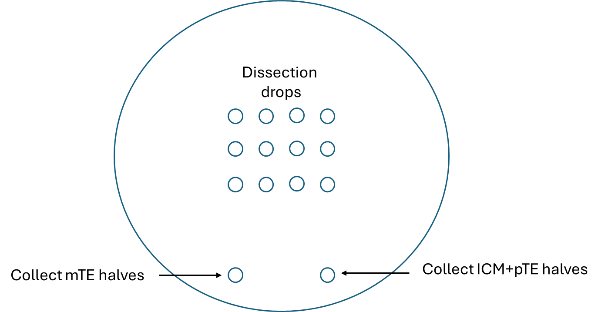

- On the micromanipulator: add a holding micropipette to the left hand side holder and a biopsy micropipette to the right hand side holder
- Put the 10 cm Petri dish on the heated stage of the micromanipulator to prewarm
- Lower the micropipettes into the Petri dish and adjust them so they are aligned to each other and in the field of view; take up a bit of oil and medium in each pipette while ensuring the liquid does not go far up the pipette and into the tubing!
It might help to have the oil-medium meniscus close to the bottom of the holding pipette and at the far right field of view for the biopsy pipette.

The biopsy pipette has a much stronger grip of the embryo compared to the holding pipette.

- Practice moving liquid up and down the pipettes until you feel you are in full control of the movement

- Once you are comfortable with the pipette setup, add embryos to the dish, wash them through a few drops and add 1 embryo/drop for dissection.

- Hold the embryo with the holding pipette on the side opposite the ICM.

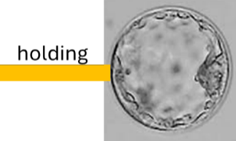

- Use the laser to drill a small hole in the Zona and the mural TE to collapse the blastocoel cavity.
denotes laser targeting

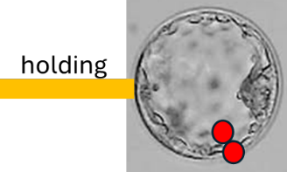

You can use the biopsy and holding pipettes to squeeze gently the embryo to help collapse it.

- Use the laser to dissect out the Zona on the side of the ICM.

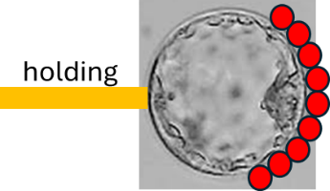

- Use the biopsy pipette to hold the embryo on the ICM side where you removed the Zona

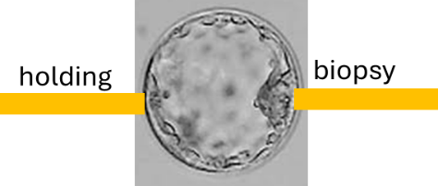

- Pull the holding and biopsy pipettes in opposite directions to hatch the embryo from the Zona. Release the Zona from the holding pipette far from the embryo.
Alternative to steps above: hold the embryo + Zona with the biopsy pipette, laser a hole in the Zona on the side opposite the ICM and use the holding pipette to gently hatch the embryo from the side opposite the ICM.

- Hold the hatched embryo with both pipettes. Use the laser to dissect the ICM + polar TE, firing far away from the ICM

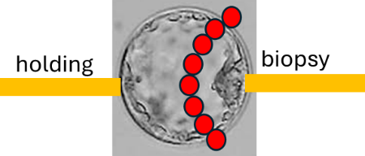
- Pull the holding and biopsy pipettes in opposite directions to separate the mural TE from the ICM + polar TE

- You may have to repeat the last two steps a number of times (sometimes 10-15x) to complete the separation

- Gently expel the embryo halves from the micropipettes. Use a stripper tip to collect the mTE halves in the bottom left drop and the ICM+pTE halves in the bottom right drop of the Petri dish

