Standard Operating Procedure
SOP Ref No. CTR/Niakan/011
Version:

SOP title:

Human ESC derivation
Project supervisor

Kathy Niakan
Author

Desislava Staneva, October 2025

Please acknowledge our work if you use or adapt these protocols in your research.
Purpose
This Standard Operating Procedure (SOP) outlines the step-by-step protocol for the derivation of human embryonic stem cells (hESCs) from thawed human blastocysts. It includes the preparation and handling of media and culture substrates, thawing of embryos, plating onto inactivated mouse embryonic fibroblast (MEF) feeder layers, laser-assisted microdissection of the inner cell mass (ICM), and the passaging, expansion, and maintenance of hESC outgrowths. The overall aim is to establish genetically stable and morphologically consistent hESC lines under defined naïve culture conditions using PXGL or UXGL medium formulations.
Materials and equipment
In this SOP, they will be detailed before each section.
Procedure
Day 1
- Equilibrate a dish with media covered with oil in the Embryoscope for at least 16 h.
PPE | Consumables | Equipment
Lab coat  Gloves  Safety goggles | EmbryoSlide+ culture dish, Cat. 16454 or 16450, Vitrolife  Relevant Embryo media  Mineral oil, Cat. ART-4008-5PA, Cooper Surgical/Origio | Embryoscope+ incubator, Vitrolife

- If using EmbryoSlide+ dishes (16-wells; for Embryoscope):
  - 30 µl medium in wash wells A-D
  - 180 µl medium in each of the two reservoirs
  - 1.6 ml oil overlay
- If using EmbryoSlide+ ic8 dishes (8 wells; for Embryoscope):
  - 30 µl medium in wash wells A-D
  - 20 µl medium in each of the eight culture wells
  - 1.6 ml oil overlay
- If using a 35 mm dish:
  - ~10 drops, 20 ul each
  - 2.5 ml oil overlay

Note: many human embryo media (e.g. Global, Gx-TL) require 6% CO₂ for correct pH.

- Plate inactivated MEFs onto 4-well dishes the day before embryo plating.

PPE | Consumables | Equipment
Lab coat | 4-well culture dish (Nunclon Delta treated), Cat. 176740, Thermo Fisher | Class II biological safety cabinet
Gloves | 15 ml conical tube, Cat. 339651, Corning | CO₂ incubator (37 °C, 5% CO₂)
Safety goggles | MEF medium (recipe and Cat numbers below) | Benchtop centrifuge (300 g 5 min)
 |  | Inverted phase-contrast microscope
 |  | Water bath (37 °C)

MEF medium
Component | Cat number, Company | Final conc.
Advanced DMEM/F12 | Cat. 12634-010, Gibco | -
FBS (heat inactivated) | Cat. F9665-500ML, Sigma/Merck | -
GlutaMAX 100X | Cat. 35050-038, Gibco | 1x
Pen/Strep 100X | Cat. 15140-122, Gibco | 1x
2-mercaptoethanol |  | 0.1 mM

- Thaw MEFs in a water bath, add to 5 ml MEF medium to dilute out the cryoprotectant
- Centrifuge 300 g 5 min RT, discard S/N
- Resuspend pellet in MEF medium
- Plate ~ 350,000 cells/well of a 4-well dish (Nunclon Delta treated)
- Let cells attach to dish overnight before plating the embryos

MEFs don’t like the naïve (PXGL) medium so keep in MEF medium until you are ready to plate embryos.

If usure about MEF density, plate a range of several different densities and choose the most optimal one on the day of embryo plating.

Day 2
- Replace MEF medium with naïve cell PXGL medium.
PPE | Consumables | Equipment
Lab coat | PXGL medium (recipe and Cat numbers below) | Class II biological safety cabinet
Gloves |  | CO₂ incubator (37 °C, 5% CO₂)
 |  | Inverted phase-contrast microscope

Inspect MEFs – they should have attached to the dish and have elongated morphology.
- use P100 to gently remove the MEF medium
- rinse each well once with 1 ml PXGL medium
- add 1 ml PXGL medium/well
- return to incubator for at least 2 h to equilibrate before plating the embryos

PXGL medium
Component | Cat number, Company | Final conc.
N2B27 basal medium (NDiff227) | Cat. Y40002, Takara
PD03* |  | 1 µM
XAV939 |  | 2 µM
Go6983 |  | 2 µM
hLIF |  | 10 ng/µl
Pen/Strep 100X | Cat. 15140-122, Gibco | 1X
* PD03 can be replaced with 5 µM Ulixertinib to make a UXGL medium (ref: Simon et al, 2025, Nature Communications)

- Thaw Day 5 or 6 human blastocysts.

PPE | Consumables | Equipment
Lab coat | EmbryoSlide+ culture dish, Cat. 16454 or 16450, Vitrolife | EmbryoScope+ incubator, Vitrolife
Gloves | Relevant Thawing kit | Stereo/dissecting microscope
Safety goggles | 10 cm Petri dish, Falcon | Water bath (37 °C)
 | Stripper tips, Origio | Timer
 | Mineral oil, Cat. ART-4008-5PA, Cooper Surgical/Origio | Liquid nitrogen bath
 |  | Heated stage (optional)

If using EmbryoSlide+ culture dishes, it’s important to remove bubbles from the dishes before loading the embryos:
- use a stripper tip to pipette up and down in each microwell; this causes any bubbles to float up
- use a P200 to pipette out the bubbles floating at the top of the dish; be careful not to aspirate too much medium/oil
- return dishes to incubator

Transfer embryo straws in a liquid nitrogen bath and keep submerged until ready to thaw. During thaw, it’s important to move quickly from LN2 to the first thawing solution.

Use the manufacturer’s protocol for each thawing kit.

If using the Kitazato kit for thawing vitrified embryos:
- Pre-warm the TS solution to 37 C in a water bath for at least 30 min. Invert tubes to mix.
- Pre-warm the DS and WS solution to room temperature for at least 30 min. Invert tubes to mix.

Thaw embryos is a 10 cm Petri dish (see schematic below):
- Add solutions to the dish just before use
- Make a small wash drop next to each thawing solution drop to rinse the stripper tip before embryo transfer in the corresponding solution
- TS: 500 µl 1 min 37 C
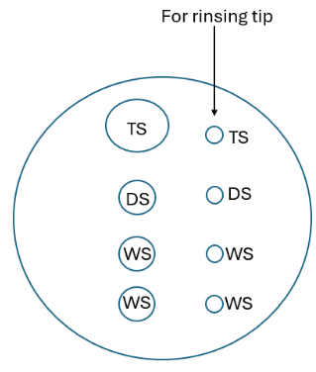
- DS: 50 µl 3 min RT
- WS: 50 µl 5 min RT [wash #1]
- WS: 50 µl RT [wash #2], keep embryos there until ready to move to culture dish

Wash embryos through ~4 wash wells/drops of the culture dish and place them in the
Incubator.
Embryos should be transferred to the incubator ideally within 30 min and maximum within an hour of starting the thaw. If many embryos are being thawed, transfer them in batches to the incubator.

Let embryos recover from the thawing for 4 h to overnight before plating onto MEFs.

- Plate embryos onto MEFs.

Blastocysts can be plated whole (after Zona removal) or dissected in half and only the ICM half plated (recommended).

Zona removal can be done with Acidic Tyrode’s or using a micromanipulator to hatch the blastocysts (recommended).

  - Laser dissect the ICM + polar TE and plate onto MEFs (see videos on mouse and human microdissection).
Use heated stage of micromanipulator.
Use the laser in biopsy mode and reduce the number of holes to a minimum to prevent suturing of cells.
Take images of each embryo prior to dissection.

- Make 20 µl drops of PXGL/UXGL medium (or HEPES-buffered embryo medium) on a 10 cm Petri dish lid and cover with oil; wash the embryos through a few drops and add 1 embryo/drop for dissection.
- Hold the embryo with the biopsy pipette on the side of the ICM.
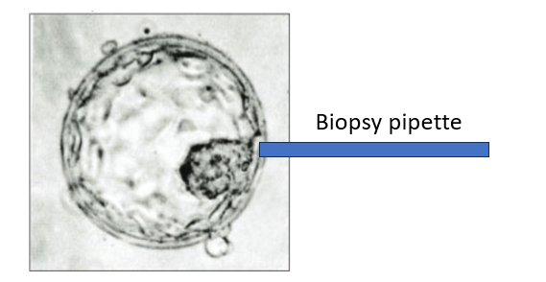

- Use the laser to drill a small hole in the ZP and mural TE to collapse the blastocoel cavity.
denotes laser targeting

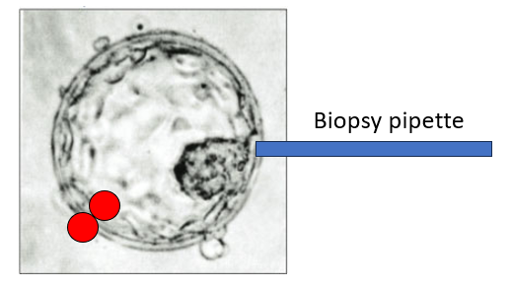
You can use the biopsy and holding pipettes to squeeze gently the embryo to help collapse it.

- Use the laser to dissect out the Zona on the side opposite of the ICM.
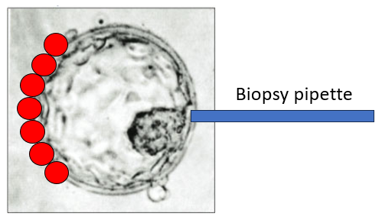

- Use the holding pipette to hold the embryo on the side where you removed the Zona (opposite the ICM).

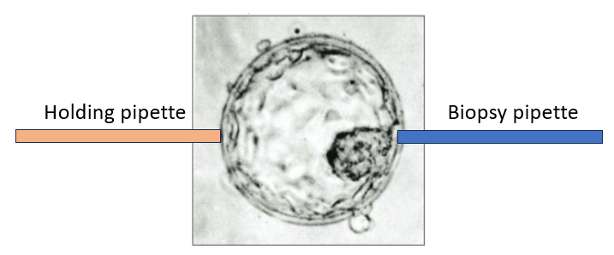

- Pull the holding and biopsy pipettes in opposite directions to peel off ZP away from the embryo

Alternative to steps d-e: hold the embryo + Zona with the holding pipette, laser a hole in the Zona on the side of the ICM and use the biopsy pipette to gently hatch the embryo from the ICM side.

- Use the laser to dissect the ICM + polar TE, firing far from the ICM
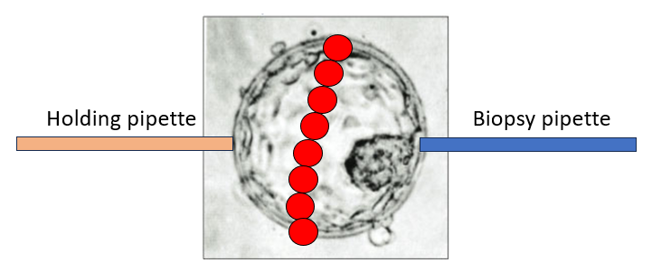

- Pull the holding and biopsy pipettes in opposite directions to separate the mural TE from the ICM + polar TE

- You may have to repeat steps g and h a number of times (sometimes 10-15x) to complete the separation

  - Plate Passage 0 (P0) outgrowths.
- Transfer the ICM + polar TE to the 4-well dishes with MEFs using a stripper tip.
- Place one dissected embryo in the middle of a well, then add media on top with the stripper tip to sink the embryo.
- Place the 4-well dishes at 37 C, 5% CO₂, 5% O₂ and minimize opening of the incubator for 24 h.

Day 4

1. Half media change (2 days after plating).

It’s important to have the outgrowths always submerged in media – hence half media rather than full media changes.

Visually inspect the outgrowths which should have attached to the MEFs.

Using P1000, carefully remove 400-500 ul media from each well. Take media from the side of the well, away from the outgrowths and MEFs.

Add 400-500 ul prewarmed PXGL/UXGL to each well. Add the media to the side of each well to avoid disturbing the outgrowths and MEFs.

Return the 4-well dishes at 37 C, 5% CO₂, 5% O₂ for another 2 days.

After Day 4: half media change every other day until the outgrowths are ready to be passaged (should be around day 7).
Example Day 7 outgrowth images below:

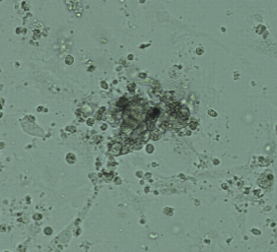
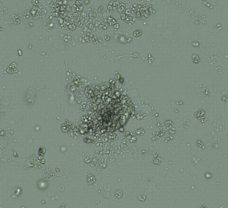
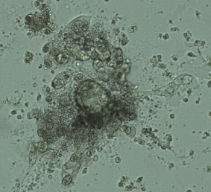
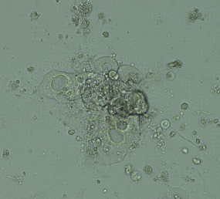
1 2 3 4

A

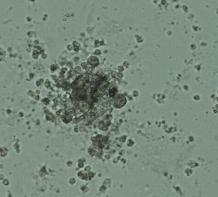
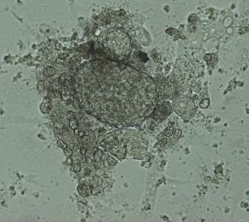
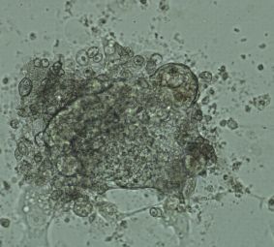
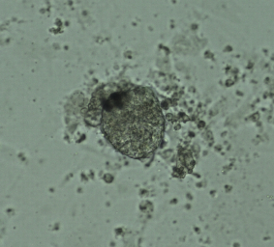

B

Outgrowths A2, B1, B2 and B3 (you can see the formation of dome-shaped structures characteristic of naïve hESC colony shape).

First passage of outgrowths

The timing of the first passage may vary depending on how fast the cells have grown (usually days 7-10 days after embryo plating)

- Wash each well with MEFs plated the day before with 1 ml PXGL/UXGL.
- Add 1 ml PXGL/UXGL + ROCKi (10 uM final concentration) to each well
- Half media change for each well with P0 outgrowth: remove 500 ul and add 500 ul fresh PXGL/UXGL (this is to keep the original outgrowths growing in case there’s a problem with P1)
- Prepare the dishes shown below for each outgrowth to be passaged:
- A 4-well dish with 500 ul PBS -/- per well
- A 35 mm dish with Accutase and PXGL/UXGL drops
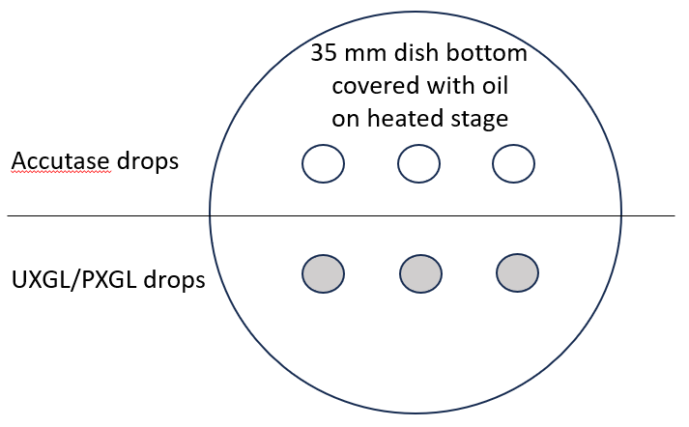

- Scrape off each outgrowth with a stripper tip, minimizing the MEFs you take. Steady your hand on the dissecting microscope, and scrape left (towards 9 o’clock), then right (towards 3 o’clock). The scraped outgrowths will float – wait a few seconds for them to start sinking for easier pickup.
Keep these dishes with the original outgrowth – return them to the incubator in case there’s contamination or other problems with the new dishes that you make today.

- Use the stripper tip to transfer the outgrowth into PBS -/- and wash quickly. At this point the outgrowths are likely to sink and stick to the bottom of the dish. To prevent that, pipette them far from the bottom and quickly transfer to another drop.

Note: Some outgrowths might start disaggregating in PBS – transfer the small clumps directly onto a MEF plate and only add the big clumps into Accutase.

- Transfer each outgrowth into Accutase: wash through 2 drops and incubate in a 3rd drop for 5 min on a heated stage.

- Transfer each outgrowth into UXGL/PXGL: wash through 2 drops and add to a 3rd drop.
- Use a 100 um stripper tip to break off the outgrowth into single cells and small clumps; pipetting up and down once is usually sufficient, though sometimes you need to pipette 2-3 times; small clumps are fine at this stage, do not over disaggregate.
- Use a stripper tip to transfer the single cells and small clumps onto a new MEF plate, spreading them evenly across the entire well. This is now P1 (passage 1). Return the 4-well dishes at 37 C, 5% CO₂, 5% O_{2 .}

- The following day: 2x half media changes to replace PXGL/UXGL + ROCKi with fresh PXGL/UXGL (no ROCKi).

After P1: half media change every other day until the outgrowths are ready to be passaged again (about 5 days later).

Second passage of outgrowths

- Wells with few colonies: can be passaged by manual picking (as described for the first passage) + subsequent enzymatic dissociation of the rest of the well as described below.
- Wells with many colonies: the whole well is passaged enzymatically:
        - remove UXGL/PXGL media from each well
        - wash with 500 ul PBS -/-
Some colonies may detach during this step – be careful not to pipette them out when removing the PBS
        - add 500 ul Accutase and incubate at 37 C in the incubator for 5 min
        - gently pipette up and down 3 times with a P1000 to disaggregate the cells
        - transfer the cells to a falcon with 500 ul PXGL/UXGL
        - spin 300 g 5 min
        - pipette out the S/N, leaving some behind (don’t aspirate)
        - resuspend the cells in ~ 200 ul PXGL/UXGL + ROCKi and add to fresh MEFs plated the day before;
each well should have about 1 ml of PXGL/UXGL + ROCKi
        - 2x half media changes the following day to dilute out the ROCKi

Third and subsequent passages of outgrowths

These should be done enzymatically as described above.

Freeze down cells in a solution of 10% DMSO 90% FBS (filtered) as soon as the cell line looks stable (lots of colonies growing well on the well). See example images below:

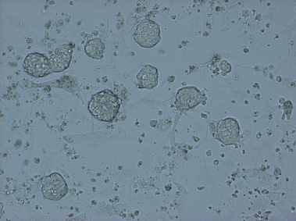
- cells ready to be frozen

- cells not ready to be frozen
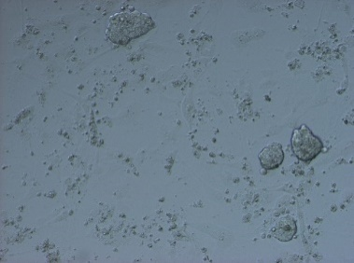
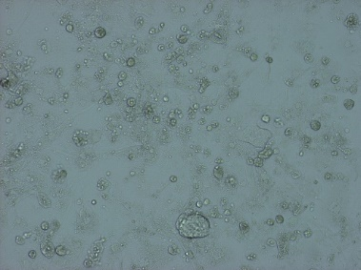

Other tips
- If some cell lines are struggling to grow, you can add fresh MEFs on top to try and revive them. Try growing a struggling cell line for at least 7-10 days by adding fresh MEFs every 3-5 days before discarding the plate.
- MEFs don’t like PXGL/UXGL, so they will start dying quicker than in MEF media

