Standard Operating Procedure
SOP Ref No. SOP-CTR/Niakan/002

SOP title:
Cow IVF

Project supervisor
Kathy Niakan

Author
Desislava Staneva and Esther Rosales Sanchez

Please acknowledge our work if you use or adapt these protocols in your research.
Purpose
The objective of this Standard Operating Procedure is to describe the procedure for extracting oocytes from bovine ovaries, maturating them, fertilizing them in vitro and culturing the embryos.
Materials and equipment
PPE | Consumables | Equipment
- Gloves.  - Lab coat.  - Gloves designed for handling cryogens.  - Face shield/goggles.  - Closed footwear. | - Tissue culture dish 35x10mm, Cat. 353001 Falcon.  - Petri dishes, Cat. 351029 Corning.  - Nunc™ 4-Well Dishes for IVF, Cat. 144444 Thermo Scientific.  - 50ml Conical tubes, Cat. 430829 Falcon.  - 1ml syringes, Cat. 303172 BD Plastipak.  - Agani Needle 18Gx38mm Pink, Cat. SYR6222 Terumo.  - Pasteur Pipettes Graduated 5ml, Cat. 1CC2.1 Carl Roth.  - Micro Pipettes.  - Slide Fast-Read 102, Cat. 630-1893 Kova International.  - 1x Phosphate Buffered Saline, Cat. BR0014G Oxoid. Autoclaved.  - WASH-Oocyte and Embryo wash medium, Cat. 51002 E.E.G Technologies LTD.  - BO-SEMENPREP - Bovine Semen Preperation Medium, Cat. 71003 E.E.G Technologies LTD.  - BO-IVM - Bovine Oocyte Maturation Medium, Cat. 71001 E.E.G Technologies LTD.  - BO-IVF - Bovine Fertilisation Medium, 71004 E.E.G Technologies LTD.  - BO-IVC - Bovine Embryo Culture Medium, 71005 E.E.G Technologies LTD.  - Oil for Tissue Culture, Cat. ART-4008-5P Cooper Surgical.  - Heparin sodium salt, Cat. H3149-25KU, Sigma-Merck.  - Bull semen straws - Heronbrook Poseidon, UK Sire Services Ltd.  - Sodium Chloride, Cat. S/3120/60, Fisher scientific. | - Water bath 15L in G4, Cat. SWB15D Stuart.  - Water bath 6L in E30, Cat. SWB6D Stuart.  - MARS 1200 IVF hood in E30, Cat. WM1200E-W5240 Cooper Surgical.  - 14L Gold CO2 Incubator in E30, Cat. 14G-230 GS Biotech.  - Flatbed Incubator (hypoxic) in G4, Cat. K-MINC-1000 Cook medical.  - Thermos.  - Hot plate in E21, Cat. MH6616 Electrothermal.  - G95 Portable Incubator in E30, Cat. K22076 K-Systems.  - Centrifuge 5702 in E30, Eppendorf.

Procedure
Prepare these the day before performing this procedure. These steps must be done with gloves and lab coat:
- 2x 1 L PBS bottles pre-warmed in the hypoxia incubator in E21; these are for washing the ovaries before oocyte extraction.
- 2x 1 L PBS bottles pre-warmed at 42 C in a water bath (for the ovary transport in the thermos); the higher temperature is to compensate for heat loss during transport.
- 3x 35 mm dishes pre-warmed empty in a CO2 incubator. These are for Bo-Wash.
- 2x 15 ml falcons with 10 ml Bo-Wash each pre-warmed in the portable incubator.
- Heparin aliquot of 150 uL at 5000U/mL.
- 1x empty 50 ml falcon pre-warmed in the portable incubator.
- 1x 35 mm dish with 2 ml IVM (wash) equilibrated for at least 4 h (or O/N) in a CO2 incubator.
- 1x 4-well dish with 500 ul IVM/well equilibrated for at least 4 h (or O/N) in a CO2 incubator.
- Max 40-50 eggs per well; estimate how many you’ll collect the following day; 3 wells are usually enough.
- Check incubators are set to the correct temperature (38.5 C) and properly humidified.
DAY 1 (Tuesday 8:30 – 13:30): Oocyte extraction from bovine ovaries and maturation

The day of the procedure, these steps must be followed wearing gloves and lab coat.

- Turn on the heated stage in the hood in E30, draw a grid with a marker on a 10 cm dish bottom and prewarm on the heated stage. Also set up approx. 6 x 1ml syringes + 18G needles in E21.

- Collect cow ovaries from abattoir and transport them in in warm PBS solution in a thermos (alternative: 0.9% NaCl) following the SOP001. The temperature needs to be >= 30 C.

- Extract oocytes from ovaries in the E21 quarantine room wearing gloves and lab coat. This is a picture of the setup:
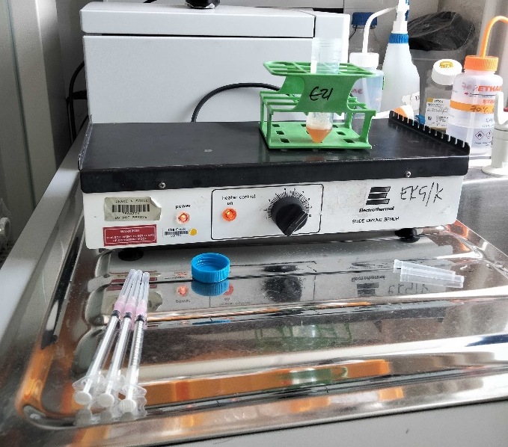

  - First, wash ovaries in thermos 2x with warm PBS in a glass beaker. Use hot plate (setting no.5) and metal falcon rack to extract. Extract at a bit lower temperature (35C).
  - Add a bit of Bo-Wash (~ 280 ul) + 140 ul heparin in a 50 ml falcon; place on hot plate.
  - Use 1ml syringe + 18G needle to aspirate follicle contents; aspirate parallel to ovary; don’t aspirate large cystic follicles; squirt to walls of 50 ml falcon. *pick oocytes from the surface of the ovaries; oocyte maturation starts from surface, moves towards the centre of the ovaries, and finally the mature oocytes are on the surface, ready to be ovulated. Change the syringe and needle approx. every 5 ovaries (this prevents clogging), before discarding the syringe, rinse it in a small volume of fresh Bo-Wash.

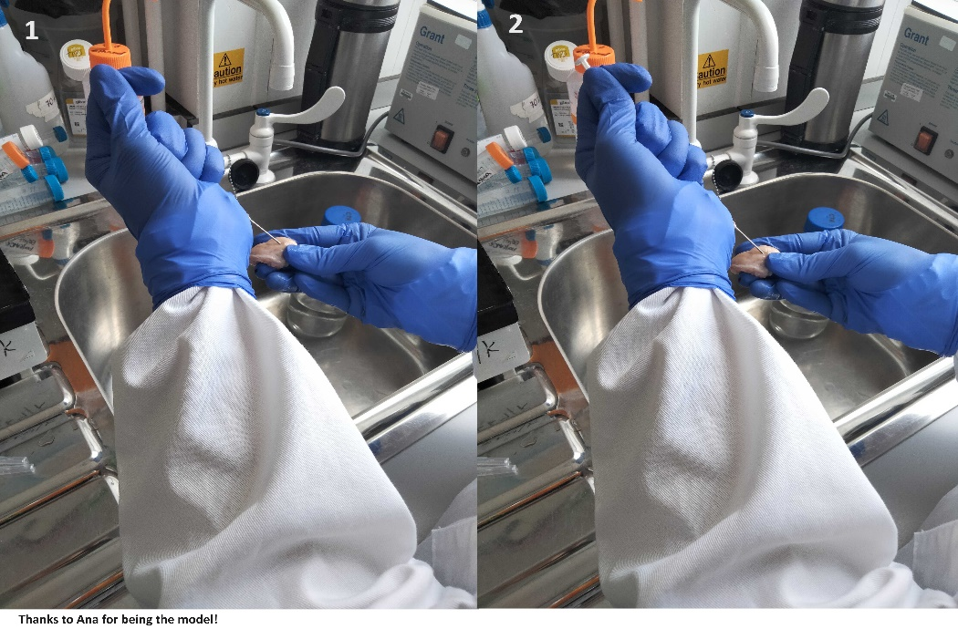
  - Incubate falcon at 38.5 C upright in the portable incubator and move to E30 immediately. The healthy oocytes will sink, and the abnormal oocytes will float. It is expected to get 3-5 oocytes/ovary.
  - The discarded material/tissue from the ovaries must be disposed in Bio-bins for anatomical waste. The bin needs to be labelled with the cost code, type of waste and the location. Leave the Bio-bin in the freezer on the A floor lined with 2 yellow bags.

- Wash oocytes and transfer to IVM for maturation in E30 embryo culture room. These steps must be done using the heated stage. To do that, take oocyte pellet with Pasteur pipette, add to a large gridded Petri dish and add more Bo-Wash on top to prevent it from drying out; the grid helps to systematically search the dish for oocytes. Pick COCs (cumulus-oocyte complexes) with P200 (set to 180 ul to avoid liquid going to the filter) and add to a small 35 mm dish with 2 ml Bo-Wash. Repeat oocyte extraction from pellet one more time. Move oocytes to a 2nd and then a 3rd Bo-Wash dish; swirl dishes to concentrate COCs in the middle for easier pick up.
* A good oocyte has several layers of cumulus cells (ideally 3); oocytes with 1 or no layer (naked) are not good.
* Cow oocytes look dark because of lipid deposits.
* Cumulus cells help with fertilization; keep for now, remove later.

- Do 1 wash in IVM (in vitro maturation) medium – contains Gonadotropins to mature oocytes to eggs. Transfer to 4-well dishes with IVM medium; max 40-50 eggs per well.

- Incubate in normoxia incubator for 20-24 h to mature the oocytes.

Prepare for the following day. These steps must be done with gloves and lab coat:
- Prewarm Bo-SemenPrep in the portable incubator: 1 x 15 ml falcon with 2 ml (mark as “sperm”) and 1 x 15 ml falcon with 3 ml (mark as “wash”).
- Prewarm 4 ml Bo-Wash outside a CO2 incubator: 2 ml (wash) + 500 ul/well to be added the following day to all wells of a 4-well dish.
- Prewarm 1x empty 4-well dish [sperm and eggs in IVF media will be added here the following day].
- Equilibrate 4 ml Bo-IVF in a CO2 incubator: 2 ml wash + 1 ml for sperm; the remaining is extra to top up the wells of a 4-well dish to 500 ul after adding the sperm).

DAY 2 (Wednesday 9-11 am): Sperm preparation and IVF

The following day, these steps must be followed with gloves and lab coat:
Sperm preparation.

- The steps when liquid nitrogen is used must be done using gloves designed for handling cryogens, face shield/goggles and closed footwear and there should be an oxygen monitor in the room. Move approx. 1-4 semen straws to a box with liquid nitrogen [ ̴1 straw is needed for 1 well of a 4-well dish). Thaw semen straws for 1 min in a water bath, dry well with paper towel.

- Cut the bottom of the straws and put the straws above a 15-ml falcon with 2 ml Bo-SemenPrep, then cut the upper end of the straws which will cause the semen to fall into the 15 ml falcon; pick up with P200 anything left in the straws.

- Shake and flick the falcon gently, don’t pipette.

- Transport at 38.5 C in the portable incubator to a falcon centrifuge; spin 300 g 5 min; remove most S/N immediately with Pasteur pipette, leaving a small amount of liquid (approx. 100 ul) on top.

- Repeat the previous wash with 3 ml Bo-SemenPrep; remove the S/N after the spin.

- Move to E30, add 1 ml Bo-IVF media to the sperm.

- Dilute sperm 1:20 (5 ul + 95 ul 3% NaCl), pipette 10 ul onto a FastRead slide, wait 3 min on a cold surface for sperm to stop moving and count 5 squares; place sperm in IVF in the normoxia incubator.

Cells / ml = (Σ cells counted in 5 squares) x dilution factor (=20) x 104.
N (=5)
Add 2 million sperm per well of a 4-well dish and top up to 500 ul/well with IVF media.

Transfer mature eggs into IVF media with sperm
* mature COCs: expanded cumulus; less dense around the egg.

- Add 500 ul Bo-Wash/well to all wells of a 4-well dish.

- Using P200 (set to 180 ul), add the matured oocytes to 2 ml Bo-Wash in a 35 mm dish.

- Move the oocytes to the top 2 wells of the 4-well dish with Bo-Wash with P200 and pipette up and down several times to remove outer sticky cumulus cells, leaving some surrounding the egg which aids IVF. Do this until the oocytes stop clumping together in a sticky cloud. Doing this in a 4-well dish rather than a 35 mm dish speeds up the process because the volume is smaller.

- Move the oocytes to the bottom 2 wells of the 4-well dish to dilute out the stripped cumulus cells.

- Count the oocytes, wash them in a 35 mm dish with IVF and transfer a maximum of 40-50 oocytes per well in the 4-well dish with IVF media and sperm.

IVF
- Incubate the 4-well dish with eggs and sperm in normoxia for 6-12 h.
* optional: place the 4-well dish in a humidifying chamber (large petri dish with paper towel moistened with sterile PBS or dH2O) in the normoxia incubator

Prepare for next step:
- Prewarm 4 ml Bo-Wash outside a CO2 incubator.
- Prewarm 2x 35 mm empty dishes (2 ml Bo-Wash will be added to each later).
- Add 3-4 ml IVC to a 35 mm dish; from there add 450 ul IVC/well in a 4-well dish, overlay the wells with ~ 300 ul oil (just enough to cover the IVC and no more).
- Equilibrate the 35 mm and 4-well IVC dishes at 38.5 C in a hypoxia incubator.

DAY 2 (Wednesday ~6-7 pm): Embryo culture

Embryo culture
These steps must be followed with gloves and lab coat:

- Transfer putative zygotes with a P200 (set to 180 ul) to a 35 mm dish with Bo-Wash, swirl.

- Repeat for a total of 2 washes.

- Strip cumulus cells and sperm from putative embryos: pipette each embryo up and down ~20 times with 135 um stripper tip.

- Optional [if you have lots of zygotes]: move out the bad looking zygotes (e.g. egg-shaped, loose ZP, local thickening) and putative unfertilized eggs (lack the perivitelline space between ZP and the cell membrane).

- Use larger (e.g. 290 um) stripper tip for subsequent embryo transfer steps.

- Wash embryos in the 35 mm IVC dish, swirl and pipette to dilute out the media.

- Transfer embryos to the 4-well IVC dish; max 40-50 embryos/well.

- Grow at 38.5 C in hypoxia.

- Next day: remove uncleaved embryos (optional – if you have lots of zygotes).

